My Trauma Triggers
Trauma Triggers are things that trigger memories of past traumatic events. Use this worksheet to identify what triggers are, and then begin developing a plan to manage them.

 | Things that I see that trigger me:
 | Smells that trigger me:
 | Sounds that trigger me:
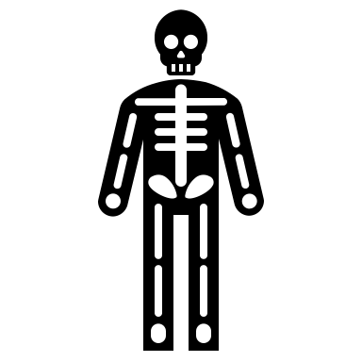 | I am triggered by the following physical feeling in my body:
 | Situations that trigger me:
 | Emotions that trigger me:
 | These places are triggers for me:

Is this a trigger I can avoid or reduce? If so, how?
____________________________________________________________________________________________________________________________________________________________

What coping skills can I use to manage my triggers when they can’t be avoided?
____________________________________________________________________________________________________________________________________________________________

Examples of coping skills:
- Take Deep belly breaths - Find a trusted person to talk to - Exercise, Run, Dance
- Practice mindfulness - Do a hobby, write, draw, colour - Stretch or yoga poses
- Use encouraging self-talk - Think of a peaceful/self-place

